What is Map?

In map, we want that for every value, there should be corresponding key so that we can fetch/search value on the basis of its key values.

Map is also a good example of Generics. Look at the following screen shot. Here ‘K’ or ‘V’ can be any valid type say ‘String’ or ‘Integer’ etc.

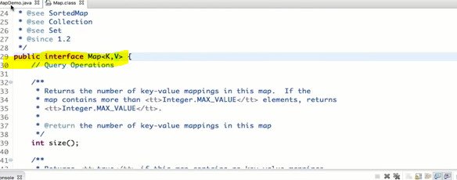

Que: Difference between Map with the Set and List

Answer: In Map, the values are fetched on the basis of Keys whereas on the other hand, values are fetched on the basis of index in Set and List.